A picture containing clipart

Description generated with very high confidence

Azure 103 Module 4

Hands On - 15

Azure Certification Training

[**support@intellipaat.com**](mailto:support@intellipaat.com)

**+91-7022374614**

**US: 1-800-216-8930(Toll Free)**

**Azure 103 Module 4 , Hands On – 15**

**Verify NSG is applied**

**Step 1:** Open the VM via RDP and Open sever manager in it and click on Add Roles and Features.

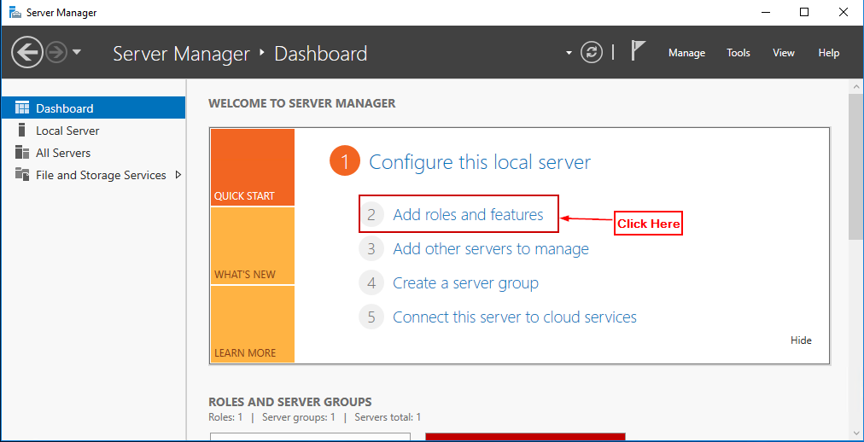

**Step 2:** Click on next and in server roles section select Web Server IIS.

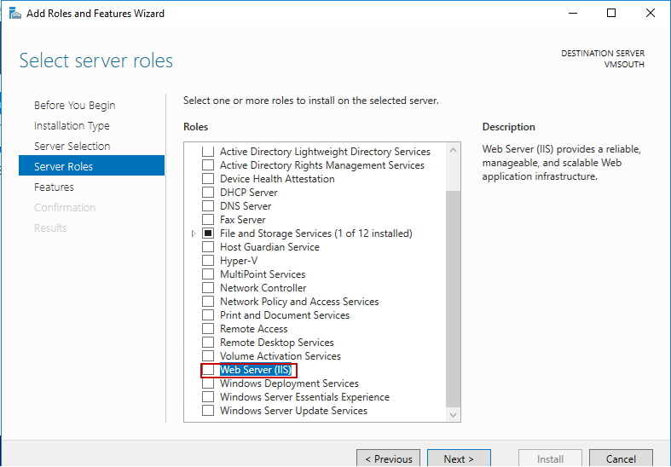

**Step 3:** Click install.

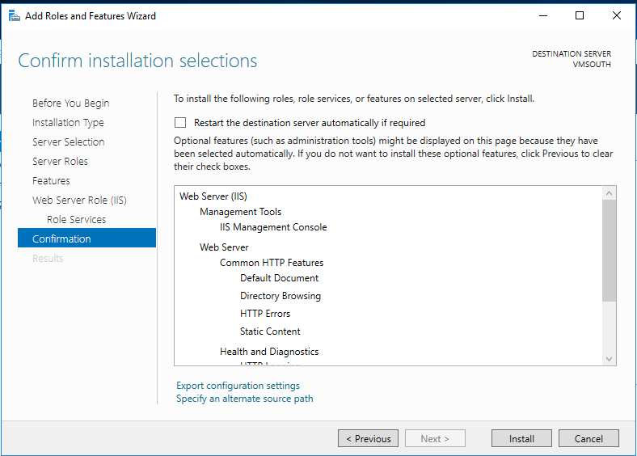

**Step 4:** Click Close.

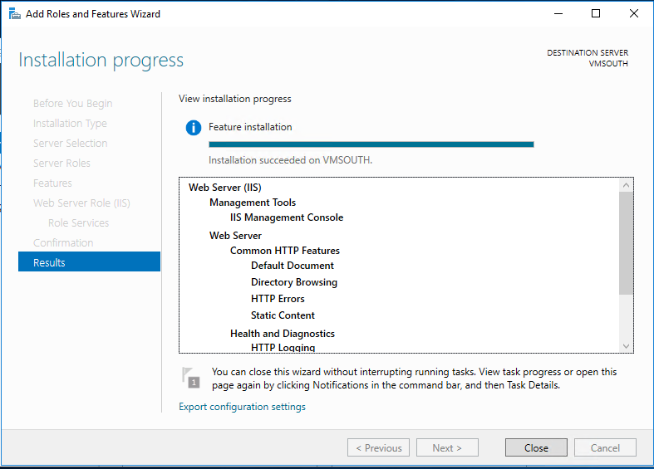

**Step 5:** Click Open ‘localhost in the VM’s web browser’.

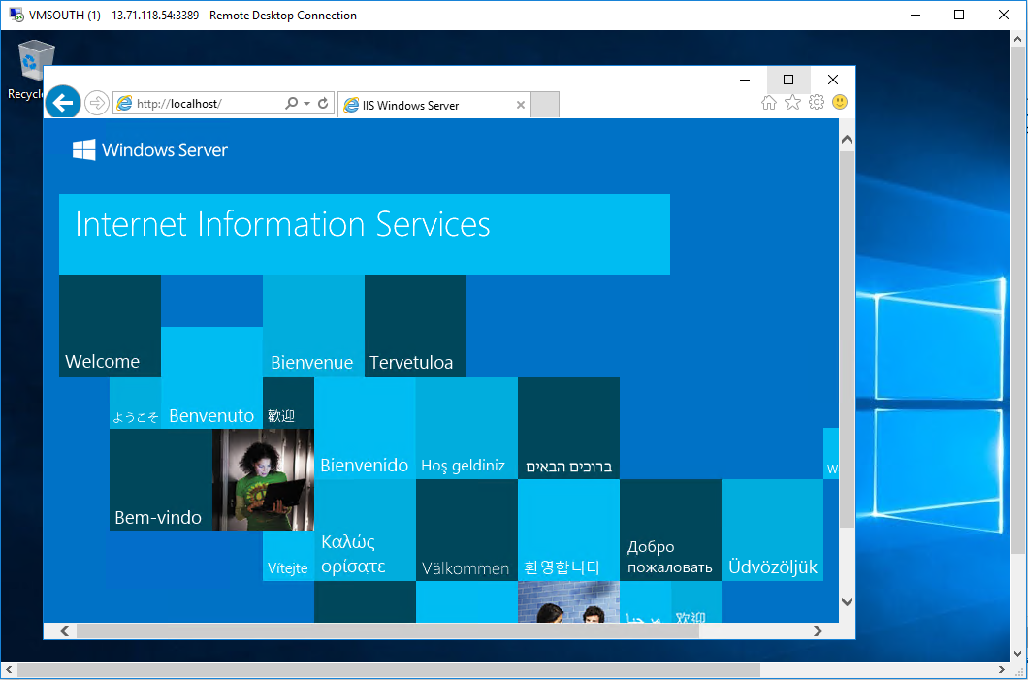

**Step 6:** Now try to access the same NIC Public IP That you were not able to access previously.

